Prewriting for “Where I’m From” Poem
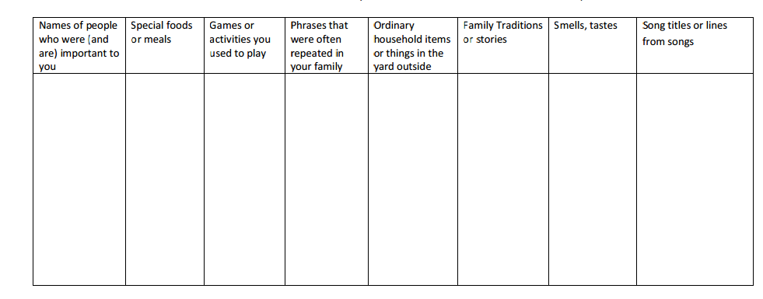
After you have finished, circle the details you would like to put in a poem. Then follow the structure below to start to write your poem.
I am from _______________________________________________________
I am from ______________________________________________________
And from____________________________________________________
I am from_______________________________________________________
From ___________________________________________________
Continue for three to four stanzas

